**Improving Sentiment Analysis in Financial News: Financial Phrase Bank Dataset Utilizing BERT Model**

|  |  |  |
| --- | --- | --- |
| **SUBMITTED BY:** | **HAMAZ RAQEEB** | **ID: (21031287)** |

**Introduction**

Sentiment Analysis is a subfield of Natural Language Processing (NLP) that specifically deals with extracting sentiments and opinions from textual content [1,2]. In addition, recent sentiment analysis techniques are incorporating various types of data, including visual information, resulting in the integration of text and visuals [3,4]. This area of study intersects with research in Affective Computing and emotion recognition [3]. As emphasized in [5], affective computing and sentiment analysis play a crucial role in advancing Artificial Intelligence (AI), offering significant potential in diverse domains and systems. Sentiment analysis involves various NLP subtasks, such as identifying sarcasm and subjectivity [9,10]. Sentiment analysis is comparable to a text classification problem, involving a sequence of operations that ultimately determine whether a given text exhibits a positive or negative sentiment [6–8]. Nevertheless, this seemingly straightforward procedure requires careful attention to details such as detecting sarcasm and subjectivity [9,10]. In addition, textual data in the real world frequently deviate from the structured format of books and newspapers [11,12]. This form of data frequently contains typographical errors, idiomatic phrases, and abbreviations. Sentiment analysis has acquired popularity in both the academic and business/government sectors.

**The objective of the Dataset:**

The primary objective of establishing the Financial Phrase Bank dataset is to collect and analyze the sentiments conveyed in financial news headlines, focusing on how retail investors interpret these sentiments. The dataset permits a comprehensive examination of affective tones in financial reporting [13].

**Exploratory Analysis:** The primary goal of the initial analysis of the Financial Phrase Bank dataset was to identify sentiments conveyed in financial news headlines, with a focus on retail investors' perceptions. The classification of emotions into negative, neutral, and positive categories. The study discovered that the majority of headlines were neutral, with some positive and diminishing negative sentiments. This study emphasizes the dataset's capacity to uncover the emotional aspects of financial news as perceived by retail investors. Figure 1 shows a representative sample of the dataset. Moreover, Table 1 shows the dataset division Fig.2 shows dataset division.

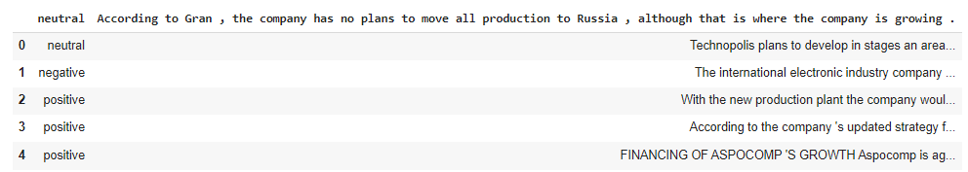

**Fig.1** Financial Phrase Bank Dataset Sentiment

|  |  |
| --- | --- |
| **Neutral** | **2871** |
| **positive** | **1362** |
| **negative** | **604** |

**Table 1. Shows dataset Division**

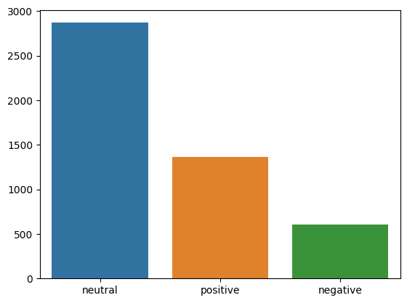

Fig.2 dataset classes

**Transformer model**

The Transformer model has significantly transformed deep learning in language tasks such as translation and text generation by incorporating self-attention mechanisms. The multi-layered structure of the system facilitates the efficient processing of diverse data by capturing contextual relationships. This research paper examines the architecture, mechanisms, and implications of the Transformer model, emphasizing its significant influence on language processing [14].

**BERT Model**

The BERT model, invented by Google, is a highly regarded language representation framework appreciated for its ability to effectively comprehend various natural language tasks. BERT uses the Transformer architecture to efficiently record word contexts by incorporating information from preceding and subsequent sentence components. This bidirectional strategy significantly enhances the model's ability to understand complexities and relationships within the written text [15].

**BERT Model Results**

The effectiveness of the BERT model in analyzing sentiment in financial news headlines is demonstrated when applied to the Financial Phrase Bank dataset. The results indicate promising performance, with a precision score of 0.89, a recall rate of 0.88, an F1-score of 0.88, and an overall accuracy of 0.85. Table 2 shows the results. The results highlight the model's ability to accurately analyze and classify sentiments, which could enhance understanding of emotional nuances in financial discussions, especially regarding the views of retail investors.Fig.3 Shows a heat map of the results.

**Table 2 Shows Results of BERT Model**

|  |  |  |  |
| --- | --- | --- | --- |
| **PRECISION** | **RECALL** | **F1-SCORE** | **ACCURACY** |
| **0.89** | **0.88** | **0.88** | **0.85** |

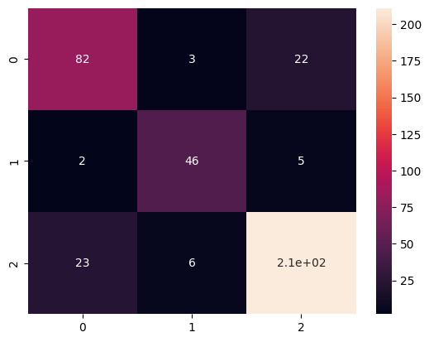

Fig.3 Diagram of Heat map

**Model Predictions**

The BERT model applied to the Financial Phrase Bank dataset demonstrates a high level of sentiment analysis prediction accuracy. The model demonstrated confidence in its classifications of sentiment by allocating high probabilities of 0.85% to both positive and negative emotions. Table 3 shows the sentiment probabilities. In addition, the model exhibited proportionate accuracy across all three sentiment classes, with a 0.84 probability for the neutral sentiment category. Moreover, Figure 4 shows the sentence and their predicted sentiments.

Table 3. Shows Accuracy across all three sentiment classes

|  |  |  |
| --- | --- | --- |
| **POSITIVE** | **NEUTRAL** | **NEGATIVE** |
| 0.85 | 0.84 | 0.85 |

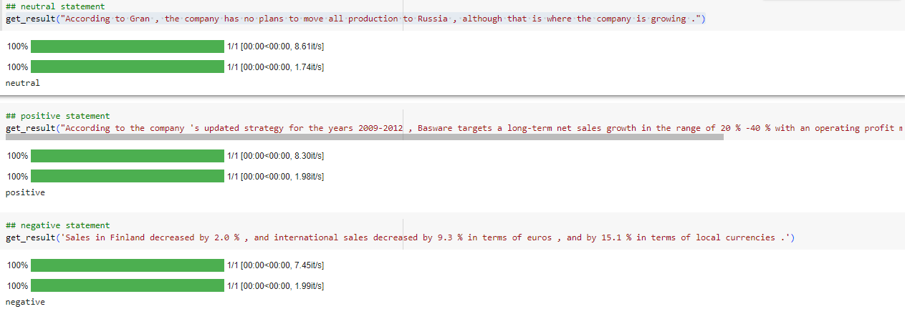

Fig 4. Shows the sentence and their sentiments predictions by BERT Model

**Google Colab Link:**

<https://colab.research.google.com/drive/1ACJcgcWftzmvsU3u_tRLJujMtrZjPj6g?usp=sharing>

**GitHub LINK: https://github.com/HHamaz123/Assignment-BERT-Model-**

**References:**

1. Yi, L., & Wen, J. (2022). Lei Lei and Dilin Liu, Conducting Sentiment Analysis. Cambridge University Press, 2021. pp. 104. ISBN 978-1-108-82921-2 (paperback), 978-1-108-90967-9 (E-book). *Language and Cognition*, *14*(4), 692-695.
2. Chaturvedi, I., Cambria, E., Welsch, R. E., & Herrera, F. (2018). Distinguishing between facts and opinions for sentiment analysis: Survey and challenges. *Information Fusion*, *44*, 65-77.
3. Poria, S., Cambria, E., Bajpai, R., & Hussain, A. (2017). A review of affective computing: From unimodal analysis to multimodal fusion. *Information fusion*, *37*, 98-125.
4. Sánchez-Rada, J. F., & Iglesias, C. A. (2019). Social context in sentiment analysis: Formal definition, overview of current trends and framework for comparison. *Information Fusion*, *52*, 344-356.
5. Cambria, E., Das, D., Bandyopadhyay, S., & Feraco, A. (2017). Affective computing and sentiment analysis. *A practical guide to sentiment analysis*, 1-10.
6. Schuller, B., Mousa, A. E. D., & Vryniotis, V. (2015). Sentiment analysis and opinion mining: on optimal parameters and performances. *Wiley Interdisciplinary Reviews: Data Mining and Knowledge Discovery*, *5*(5), 255-263.
7. Choi, Y., & Lee, H. (2017). Data properties and the performance of sentiment classification for electronic commerce applications. *Information Systems Frontiers*, *19*, 993-1012.
8. Ju, S., & Li, S. (2013). Active learning on sentiment classification by selecting both words and documents. In *Chinese Lexical Semantics: 13th Workshop, CLSW 2012, Wuhan, China, July 6-8, 2012, Revised Selected Papers 13* (pp. 49-57). Springer Berlin Heidelberg.
9. Cambria, E., Das, D., Bandyopadhyay, S., & Feraco, A. (2017). Affective computing and sentiment analysis. *A practical guide to sentiment analysis*, 1-10.
10. Valdivia, A., Luzón, M. V., Cambria, E., & Herrera, F. (2018). Consensus vote models for detecting and filtering neutrality in sentiment analysis. *Information Fusion*, *44*, 126-135.
11. Erritali, M., Beni-Hssane, A., Birjali, M., & Madani, Y. (2016). An Approach of Semantic Similarity Measure between Documents Based on Big Data. *International Journal of Electrical & Computer Engineering (2088-8708)*, *6*(5).
12. Birjali, M., Beni-Hssane, A., & Erritali, M. (2016, September). Measuring documents similarity in large corpus using MapReduce algorithm. In *2016 5th International Conference on Multimedia Computing and Systems (ICMCS)* (pp. 24-28). IEEE.
13. Mishev, K., Gjorgjevikj, A., Vodenska, I., Chitkushev, L. T., & Trajanov, D. (2020). Evaluation of sentiment analysis in finance: from lexicons to transformers. *IEEE access*, *8*, 131662-131682
14. Karpov, P., Godin, G., & Tetko, I. V. (2019, September). A transformer model for retrosynthesis. In *International Conference on Artificial Neural Networks* (pp. 817-830). Cham: Springer International Publishing.
15. Singh, M., Jakhar, A. K., & Pandey, S. (2021). Sentiment analysis on the impact of coronavirus in social life using the BERT model. *Social Network Analysis and Mining*, *11*(1), 33.